Profile
Craig is an experienced, award winning architect and healthcare specialist with a wide range of experience from masterplanning and feasibility studies to high quality detailing and the completion of construction, as well as the essential skills of project and programme management.

Craig was a director at CODA Architects for 17 years and responsible for the design and delivery of the RIBA award winning Heart Institute and Terrell Street Ward Block at the Bristol Royal Infirmary (pictured), the Princess Royal Hospital Orpington (pictured) which achieved an “excellent” rating on the NHS Environmental Assessment Tool (NEAT) and was awarded sustainable healthcare building of the year in 2006.

Recognised for his thoughtful and thorough approach to design, Craig formed stretto|architecs in 2017 to develop his passion for innovative design and attention to detail with a keen commercial awareness.

He is committed to sustainable design and the use of BIM in the delivery of construction projects with the BRI new Ward block winning the Constructing Excellence Award winner for Innovation in Design and Procurement using BIM in 2014.
Experience: Key Projects
1990 - Mid Kent Oncology Centre, £12m
1992 - Neath/Port Talbot District General Hospital, £49m
1993 - Queen Elizabeth Military Hospital extension, Greenwich, £12m
1995 - Birmingham Childrens Hospital Redevelopment, £25m
1996 - Dartford and Gravesham Acute General Hospital, £100m
2000 - Loakes Park Hospital, High Wycombe, £15m
2002 - Princess Royal University Hospital, £100 m
2004 - Private Patients Unit Bromley, £3m
2005 - Bristol Heart Institute, Bristol, £33m
2006 - Children’s A&E department, Bristol, £0.3 m
2006 - Soundwell Teaching Block/Nursery, £5m
2006 - PRUH Ophthalmology department , Bromley, £0.2m
2007 - MRI/CT suite for UBHT in new Bristol Heart Institute, £1m
2007 - John Lewis Store, Cambridge, £18m
2010 - Southville Primary School, Music block, £0.1m
2012 - New Ward Block Bristol, £80m
2012 - DCP for re-configuration of BRI, £20m
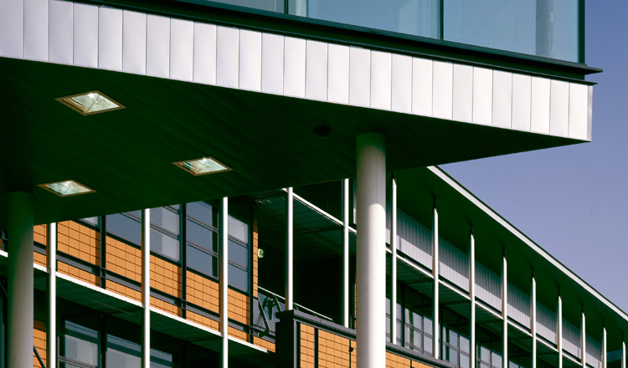
2012 - Queens Building Façade BRI with Nieto Sobejano, £3m
2014 - Dyson – various reconfiguration projects, £1m
2014 - Sancta Maria Hospital, Morriston Hospital, £12m
2016 - Bath Ales Brewery, £1m
2016 - Bristol Royal Infirmary Framework: multiple projects
2017 - Sancta Maria Hospital, SA1, Swansea, £13.5
2017 - Pharmacy Clean Rooms, Bristol Royal Infirmary, £0.25m
2017 - Physiotherapy Unit, Private Hospital Swansea, £0.2m
2018 - BRI Welcome Centre Extension, Bristol, £0.4m
2018 - BRHC Neuro Rehab Ward Refurbishment, Bristol, £0.1m
2018 - BRI Cardiovsacular Research Unit, Bristol, £6m

